Switch Case Step

Objective

The switch statement is a multi-way branch statement. It provides an easy way to dispatch execution to different parts of code based on the value of the expression. Basically, the expression can be a byte, short, char, and int primitive data types.

UI

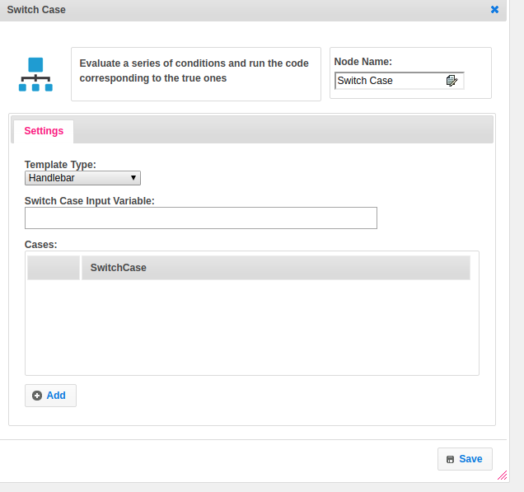

## Attributes:

|  |  |
| --- | --- |
| **Attributes** | **Description** |
| **1. Template Type** | Template type used to set the value type.  Value types are two types.  1.hb-HandleBars  2.ftl-Freemarker Template Language. |
| **2. Switch case input variable** | Variable holds the value.  The value of the expression is compared with the values of each case. |
| **3. Cases** | Case list contains the different switch case conditions.  Each case contains the bock of code as per the case. |

## Execution Description:

Checks the step-variable value contains in the cases list or not. If it contains, returns the variable value. Based on the variable value the next attribute takes care the which next step will be execution.

## Resource:

For more information about switch case please refer the following link

<https://www.w3schools.com/java/java_switch.asp>